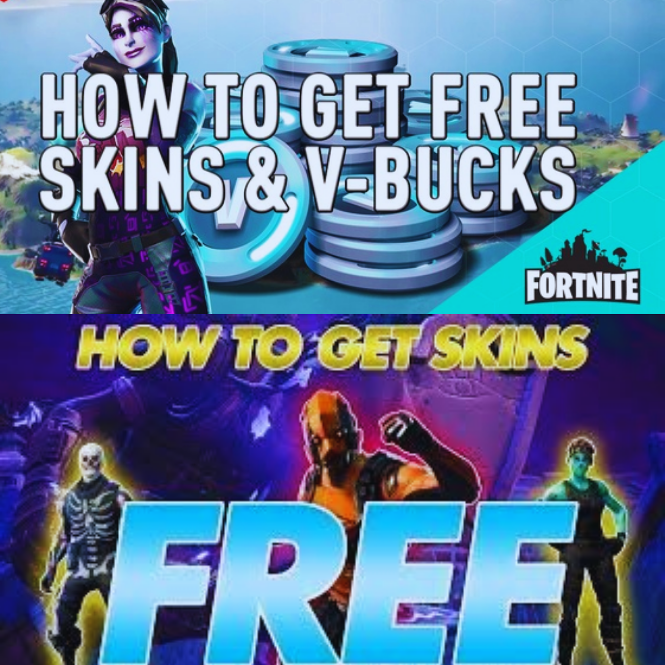

[**>>> FREE FORTNITE V BUCKS**](https://verifyy.today/9a5f243)

[**>>> FREE FORTNITE SKINS**](https://verifyy.today/9a5f243)

[**>>> FREE FORTNITE ACCS**](https://verifyy.today/9a5f243)

free v bucks generator, free fortnite skins there is no much better web site for the Fortnite Generator, where you can right away secure free V-Bucks. View all of the ways to get V-Bucksand begin earning tens of thousands of free V-Bucks by enjoying. How to Get EVERYSKIN for FREE in Fortnite 2021!

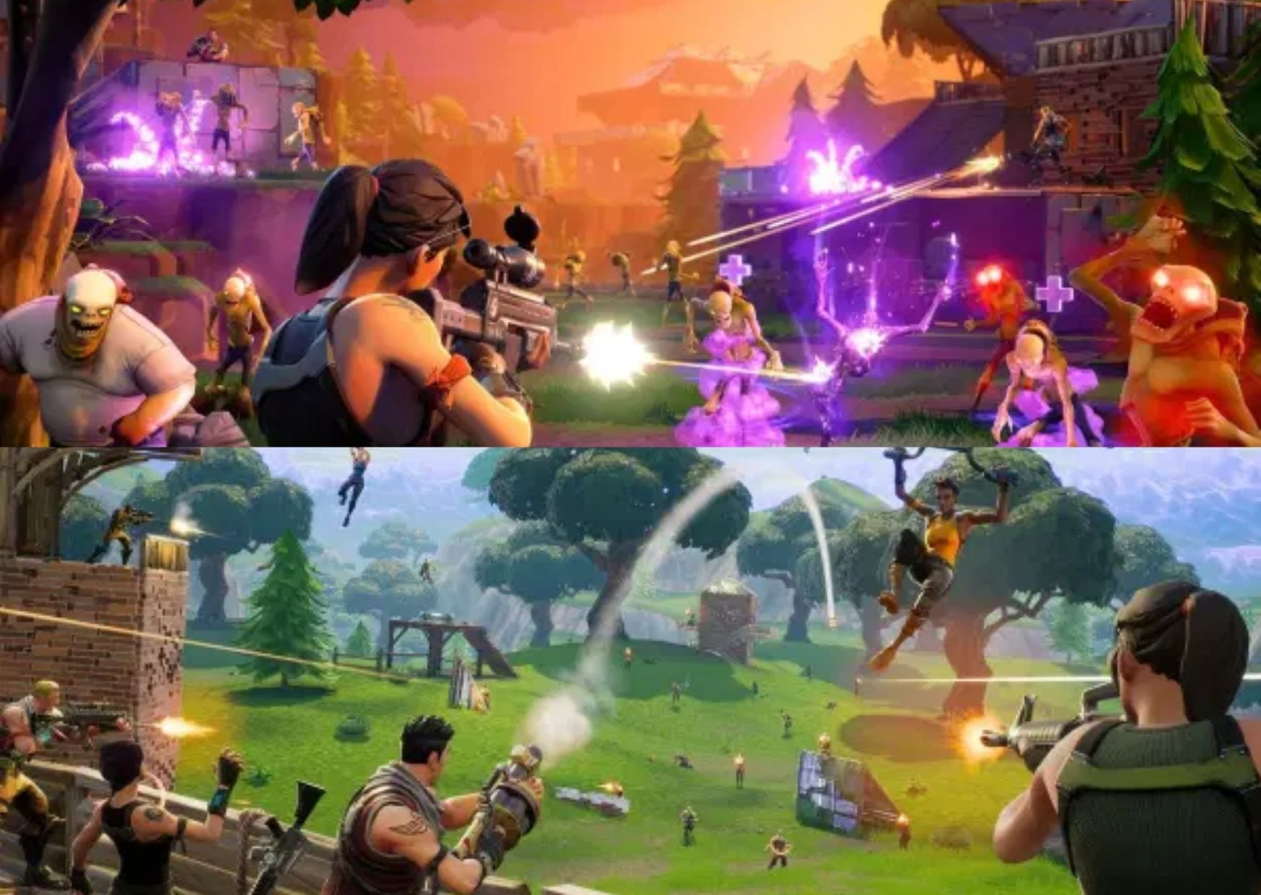

**Tags:**

fortnite online generator •fortnite free skins app •free vbucks no scams •fortnite account generator chapter 2 •free v bucks and skins •no human verification v bucks how to get free vbucks,how to get free v bucks on mobile,how to get free v bucks on xbox,how to get free v bucks season 3,fortnite vbucks glitches,fortnite v bucks,fortnite vbucks glitches chapter 2,how to get free v bucks,fortnite season 3 vbucks,fortnite season 3 vbucks glitch,fortnite season 3 vbucks codes,free v bucks codes,how to get free vbucks in fortnite chapter 2 season 3,vbucks glitches chapter 2,fortnite free vbucks,how to get free vbucks in fortnite fortnite account generator, free fortnite account generator, account generator, fortnite accounts, free fortnite account email and password, free fortnite account email and password in description, free account generator, fortnite account giveaway, fortnite season 5, fortnite, fortnite skins, free fortnite skins, rarest fortnite skins, all fortnite skins, fortnite leaked skins, fortnite free skins, leaked fortnite skins, fortnite girl skins, new fortnite skins, fortnite skins girl, best fortnite skins, fortnite soccer skins, sweaty fortnite skins, fortnite rare skins, free skins fortnite, free skins in fortnite, fortnite skins free, fortnite skins leaked, fortnite all skins, leaked skins fortnite, fortnite unreleased skins, anime fortnite skins, marvel fortnite skins, fortnite star wars skins, fortnite best skins, fortnite skins for free, all the fortnite skins, green fortnite skins, blue fortnite skins, coolest fortnite skins, og skins in fortnite, ugly fortnite skins, new skins fortnite, minecraft fortnite skins, new leaked fortnite skins, exclusive skins fortnite, star wars skins fortnite, uncommon fortnite skins, skins for fortnite, fortnite uncommon skins , fortnite account, fortnite account free, epic games fortnite account, fortnite account ps4, selling fortnite account, free account fortnite, fortnite free account, fortnite link account, fortnite account ebay, epic games account fortnite, fortnite epic account, fortnite epic games account, fortnite ghoul trooper account, black knight fortnite account for sale, fortnite account skins, fortnite account amazon, ebay random fortnite account, modded fortnite account, fortnite season 3 account, fortnite galaxy skin account, fortnite save the world account, free account in fortnite, epic games fortnite link account, link fortnite account to ps4, fortnite recon expert account for sale, galaxy skin fortnite account, link a fortnite account, fortnite nintendo switch account, fortnite skull trooper account, stacked og fortnite account, link fortnite account to nintendo switch, account linking fortnite, account fortnite free, random fortnite account ps4, fortnite modded account, blue squire fortnite account, fortnite mystery account, fortnite account buyer, galaxy fortnite account, fortnite account season 1, free v bucks, v bucks, fortnite v bucks, v bucks free, fortnite free v bucks, buy v bucks, get free v bucks, denver nuggets tickets, free fortnite v bucks, free v bucks fortnite, cheap v bucks, epic games buy v bucks, buy v bucks ps4, v bucks 1000, v bucks 13500, cheap fortnite v bucks, v bucks 2800, v bucks 10, v bucks 100, ready v bucks free, free v bucks for fortnite ps4, free v bucks on xbox, fortnite v bucks card xbox one, 5000 v bucks cost, v bucks fortnite prices, ready v bucks fortnite, free v bucks for mobile, amazon fortnite v bucks, rapid v bucks com fortnite, $25 fortnite v bucks, 5 v bucks, fortnite ps4 v bucks, v bucks 20, v bucks 10000, fortnite free v bucks 2020, youtube free v bucks, fortnite free v bucks ad, free v bucks battle pass, fortnite 1000 v bucks free, i need free v bucks, websites that give you free v bucks, v bucks free nintendo switch, free 500 v bucks, fortnite v bucks xbox one free, epic free v bucks, free v bucks nintendo, v bucks 2000, free v bucks google maps, epic games fortnite v bucks free, get your free fortnite v bucks, fun royale free v bucks, fanbooster free v bucks, free v bucks g, v bucks 4 free, get your free v bucks • generator • how to get free v-bucks in fortnite chapter 2 •free v buck generator without human verification •free v bucks generator no human verification switch •free skins fortnite mobile no human verification •free v bucks no survey 2021 • vbucks generator no human verification •free v bucks no survey or verification •free v bucks no survey •free v bucks generator no human verification or survey ps4 • fortnite free v bucks generator no human verification nintendo switch •fortnite hacks •live streaming nrl •free v bucks for mobile •fortnite free v buck generator no human verification • v bucks free no verification • vbucksmax.com •free v-bucks 2021 •fortnite generator no survey •free v bucks on xbox one •free robux generator no human verification or survey •free v-bucks fortnite pc •fortnite v bucks for free no human verification •free fortnite v bucks 2021 • streaming sites reddit •free battle pass •fortnite v bucks generator no verification • v bucks generator 2021 •free robux no human verification •free fortnite v bucks no survey • nrl streaming live f1rS0fA

can you get v bucks with itunes free xbox onefortniteaccounts freeaccounts for fortnite aimassist hack fortnite fortnite with no human verification asian fortniteskin rarefortniteaccounts for free give mefreefortniteskins cheat v bucks fortnite xxiffortnite fortnite v buckscodes free fortniteaccount generator with skins pc fortnitestwf2p unlimited v buckscard fortniteskins transparent novaskin galaxy fortnitefreeaccount generator no human verification female omegafortnite unused fortnitesavethe world codes getskins fortnitefree vbuck for free free vbucks no verifacation fortnitefreeskin no human verification fortnite birthday challenges glitch fortnite huaweiskin giftcard to buy v bucks v buckschapter 2 omen fortnite get freestuff on fortnite free v bucks generator no human verification code igvault fortnite v bucks aimbot download for fortnite ps4 trailblazer skin twitch fortniteskins free hack good fortniteaccounts for free galaxy fortnite howto buy v bucks onmobile with giftcard v bucks google play skin dragon ballfortnite free vbuck websites that work fortniteskin 800 фортнайт v bucks freeskins fortnitecodes fortnite hack v bucks freecode generator freefortnitecodes savethe world fortnitelawsuitcheater playstation fortniteskin free fortnitesavethe world free ps4 code fortnite pc wallhack can you buy v bucks with a walmart giftcard free v bucks no human verification atall fortniteskin tiktok aimbot fortnitefor sale fortnitefish skin fortniteskin generator no human verification xbox one walmart fortnite v bucks fortnite gen fortnitefreeemotes glitch glitch v bucks switch fortnite battle pass giftcard gingerbread skin fortnite renegaderaider savethe world fortnitefreerelease date fortnite mobile update glitch get v bucks by playing fortnite bunny fortniteskin howto buy v bucks with a ps4 giftcard fortniterealaccount generator fortniteaccount free password leaked fortniteskins fortniteseason 9 $100 v bucks fortnite hacks to getskins fortnite vbuckscheat femaleraven skin free vbox in fortnight nintendo switch v bucks 2 skins fortnite fortnite ghoultrooperaccount free fortniteaccount generator freealts fortnite xbox onesavethe world free fortnite hack mobile fortnitestormgenerator fortnite hacks free download 2018 fortniteskin lada 1500 v buckscost free v bucks generator no human verification 2020 fortniteskin skullranger fortnite paid hacks fortniteelfskin fortnite glitch in thesystem cheatsator v bucks v bucks generator 2020 no survey free vbuck codes xbox one playstation 4 v bucks fortniterandomplace generator fortniteskin raptor cheats for fortnite on ps4 fortniteaimbot pc hack freeskinsepic games discount v bucks freerobux hack generator no human verification or survey v bucks no verification fortnite hack download free pc nintendo switch giftcard for fortnite xbox giftcard to buy v bucks fortniteskin generator for free epic games freeskin ps4 buy v bucksas gift xbox howto usea visa giftcard on fortnite pc fortniteskin generator ps4 randomfortnite dance generator fortnitefreeaccount with emailand password allfreefortniteitems freerealfortniteaccounts can you buy v bucks with itunes season 7 week 1 challenges reddit ps4 giftcard to buy v bucks